Process:

[how to install android studio on windows 10 - YouTube](https://www.youtube.com/watch?v=XVv3lCXhsr0&t=189s)

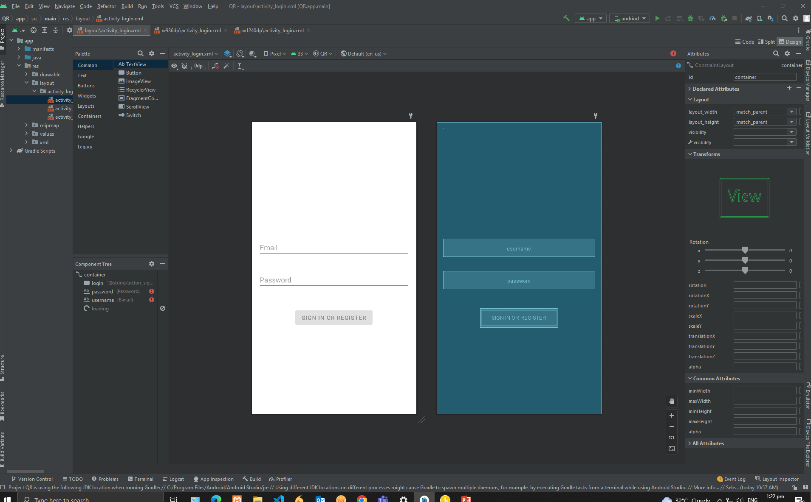Output